CARDIAB SURVEY ANALYSIS

- Twenty Divisions (91%) of the eligible 22 Divisions completed the survey: “Demographic characteristics of GPs: users and non-users”. Table 1 and 2 report the raw figures from the survey, outlining number of valid results and the various means, medians and ranges for each of the survey variables. Figures 2 – 6 graphically represent the raw data with some comparisons by RRMA.

- Some Divisions had trouble providing data for the survey. About 75% of Divisions provided data on the numbers of GP users, their gender and practice size. Fifty percent of Divisions provided answers about their GP population work hours (full time or part time) and only 35%were able to supply data about GP user age groups and place of graduation. Sixty percent of Divisions provided data about GPs and accredited practices.

- Figure one shows that the survey included slightly more metropolitan Divisions than rural Divisions, and slightly more Divisions who are in the lower disadvantage bracket. Rural Divisions had a greater proportion of users than metropolitan Divisions (see Figure 2) and there were more male GP users of CARDIAB than female GP users. There was not great variation over the different age brackets (figure 4) or practice size (figure 5) and work hours (figure 6).

- The % of GP user coverage (expressed as a percentage of total GP population) is shown in Table 3. The range of coverage extended from 4% to 100%. The mean was 35%. Some of the rural Divisions had high levels of GP user coverage. Tables 3-7 report the number of GP users and non-users as a percentage of total users and total non users respectively. These figures showed that there were significantly more users in the 45-54 age bracket and less in the 35-44 age bracket. There were also a significantly greater percentage of full time GP users than non users and lesser percentage of part time users than non-users.

Table 1
 |  | GP users total | Male GP users | Female GP users | GP users (<35) | GP users (35-44) | GP users (45-54) | GP users (55+) | GP users solo | GP users (two to four) | GP users (five+)
N | Valid | 16 | 15 | 15 | 7 | 7 | 7 | 7 | 15 | 15 | 14
 | Missing | 4 | 5 | 5 | 13 | 13 | 13 | 13 | 5 | 5 | 6
Mean |  | 40.69 | 28.53 | 10.13 | 3.57 | 5.57 | 13.57 | 5.00 | 6.93 | 13.53 | 12.64
Median |  | 41.00 | 26.00 | 9.00 | 1.00 | 5.00 | 11.00 | 4.00 | 4.00 | 9.00 | 9.00
Minimum |  | 8 | 5 | 3 | 0 | 0 | 6 | 1 | 1 | 1 | 1
Maximum |  | 76 | 59 | 27 | 14 | 17 | 23 | 12 | 25 | 33 | 43
Sum |  | 651 | 428 | 152 | 25 | 39 | 95 | 35 | 104 | 203 | 177

Table 2
 |  | GP users (full time) | GP users (part time) | GP users (accredited) | GP users (graduated outside Australia)
N | Valid | 10 | 10 | 12 | 7
 | Missing | 10 | 10 | 8 | 13
Mean |  | 27.70 | 13.700 | 31.67 | 5.00
Median |  | 29.50 | 4.000 | 35.00 | 5.00
Minimum |  | 6 | 1.0 | 5 | 2
Maximum |  | 50 | 104.0 | 56 | 8
Sum |  | 277 | 137.0 | 380 | 35

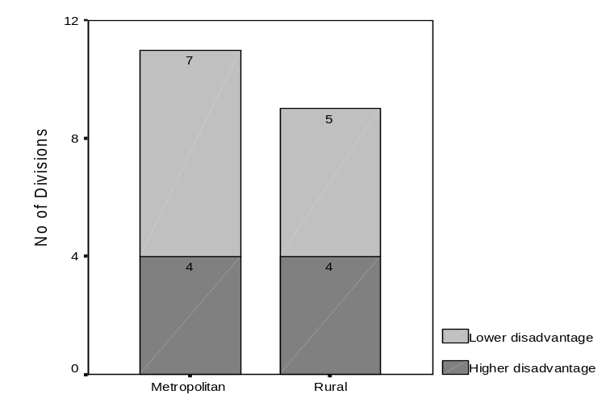 | 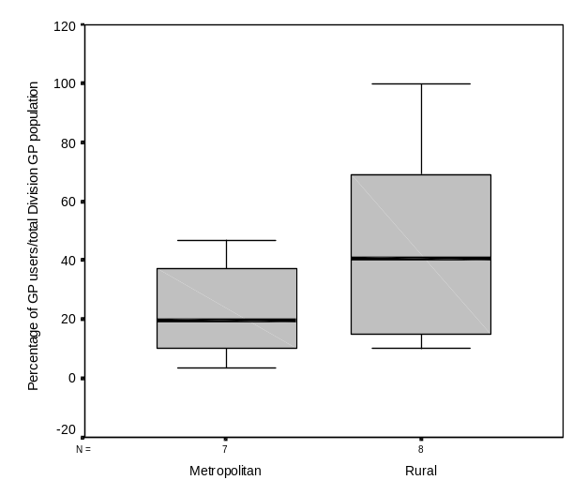
Figure: 1: Survey Divisions compared by RRMA and socio-economic index | Figure 2: Means, range and quartile spread of GP reach compared by RRMA
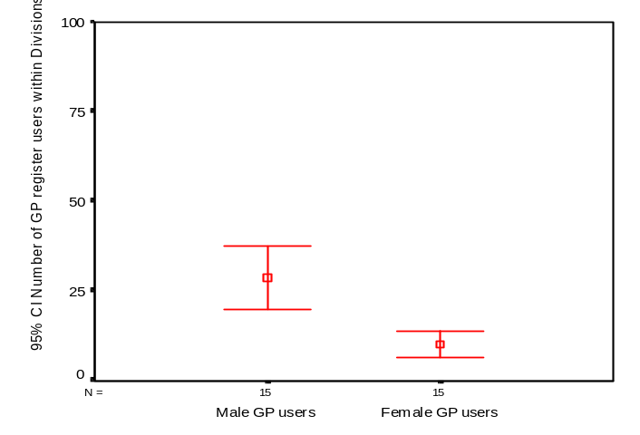 | 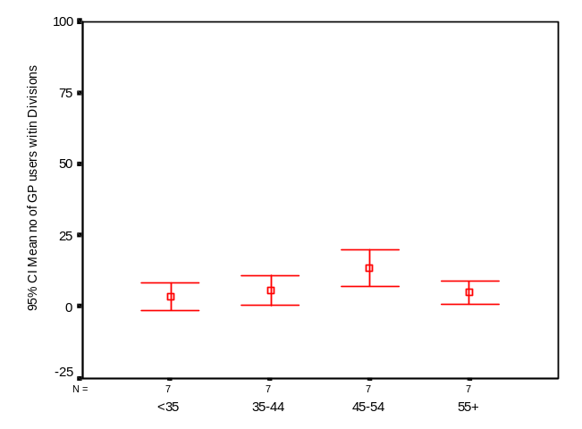
Figure 3: Error bar plot (95%CI) Mean number of GP users in Divisions by gender | Figure 4 Error bar plot (95%CI) Mean number of GP users in Divisions by age group
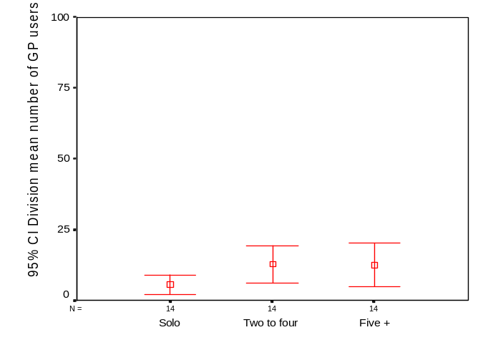 | 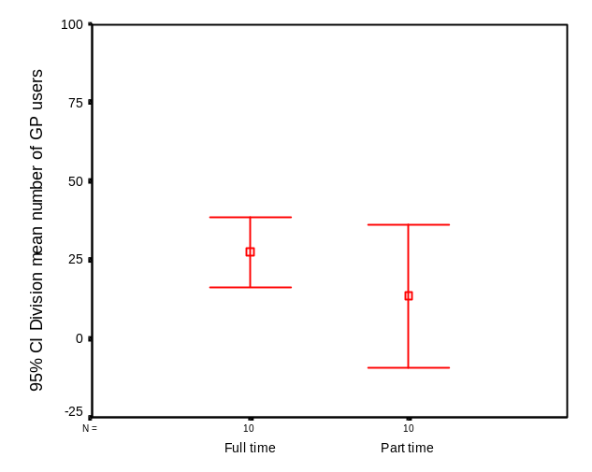
Figure 5: Error bar plot (95% CI) Mean number of GP users in Divisions by practice size | Figure 6: Error bar plot(95%CI) Mean number of GP users in Divisions compared to work hours

Table 3
ID | RRMA | SEIFA | User coverage % | % male GP users | % male GP non-users | % female GP users | % female GP non-users
1 | Metropolitan | Higher disadvantage | 20 | 64.5 | 61.7 | 35.5 | 38.3
2 | Rural | Higher disadvantage
3 | Metropolitan | Lower disadvantage
4 | Metropolitan | Higher disadvantage | 4 | 55. 6 | 65.1 | 44.4 | 34.8
5 | Rural | Higher disadvantage | 11 | 62.6 | 81.0 | 37.5 | 19.1
6 | Metropolitan | Higher disadvantage | 41 | 73.5 | 71. 7 | 26.5 | 28.3
7 | Rural | Lower disadvantage | 91 | 76.5 | 60.0 | 23.5 | 40.0
8 | Metropolitan | Lower disadvantage
9 | Rural | Higher disadvantage | 19 | 77.5 | 77.8 | 22.5 | 22.2
10 | Metropolitan | Higher disadvantage | 34 | 91.7 | 57. 5 | 8.3 | 42.5
11 | Metropolitan | Lower disadvantage | 47 | 83.1 | 72.5 | 16.9 | 27.5
12 | Rural | Lower disadvantage | 10 | 61.1 | 68.9 | 38.9 | 31.1
13 | Metropolitan | Lower disadvantage | 13 | 58.1 | 69.0 | 41.9 | 31.0
14 | Rural | Higher disadvantage | 40 | 85.7 | 62.6 | 14.3 | 37.4
15 | Rural | Lower disadvantage | 47 | 70.3 | 61.0 | 29.7 | 39.0
16 | Rural | Lower disadvantage | 42
17 | Metropolitan | Lower disadvantage
18 | Rural | Lower disadvantage | 100 | 65.0 |  | 35.0
19 | Metropolitan | Lower disadvantage
20 | Metropolitan | Lower disadvantage | 7
Mean |  |  | 35 | 72 | 67 | 28 | 33
Median |  |  | 34 | 72 | 67 | 28 | 28
95%CI |  |  | 19.0-51.0 | 64.3-79.0 | 62.7-72.1 | 21.0-35.7 | 27.9-37.3
One sample t-test |  |  |  | t=1.719; df=14; p=0.108 |  | t=-1.719;df=14;p=0.108

Table 4
ID | % <35 GP users | % <35 GP non-users | % 35 – 44 GP users | % 35 – 44 GP non-users | % 45 – 54 GP users | % 45 – 54 GP non-users | % 55+ GP users | % 55+ GP non-users
1
2 | 0 |  | 30.0 |  | 45.0 |  | 25.0
3
4 | 0 | 13.4 | 11.1 | 32.4 | 77.8 | 31.6 | 11.1 | 18.6
5 | 12.5 | 3.2 | 0 | 36.6 | 75.0 | 33.3 | 12.5 | 27.0
6
7 | 27.5 | 0 | 33.3 | 60.0 | 37.3 | 40.0 | 23.5 | 0
8
9
10
11
12 | 5.6 |  | 16.67 |  | 61.1 |  | 16.7
13
14 | 2.4 | 1.6 | 16.67 | 17.09 | 47.6 | 31.3 | 21.4 | 10.9
15
16
17
18 | 20.0 |  | 12.5 |  | 57.5 |  | 10.0
19
20
Mean | 11 | 5 | 15 | 37 | 59 | 34 | 17 | 14
Median | 7.4 | 2.4 | 13.9 | 34.3 | 61 | 34 | 17 | 15
95%CI | -9.3-30.4 | -5.1-14.1 | -6.8-37.4 | 8.3-64.7 | 27.5-91.4 | 27.6-40.5 | 7.2-27.1 | -4.1-32.4
One sample t-test | t=1.161; df=6;p=0.290 |  | t=-3.903;df=6;p<0.05 |  | t=4.4048;df=6;p<0.05 |  | t=1.357;df=6;p=0.224

Table 5
ID | % solo GP users | % solo GP non-users | % 2 – 4 practice size GP users | % 2 - 4 GP non-users | % 5+ practice size GP users | % 5+ GP non-users
1 | 5.3 | 10.9 | 38.2 | 31.0 | 56.6 | 59.7
2 | 10.0 |  | 60.0 |  | 30.0
3
4 | 11.1 |  | 66.7 |  | 33.3
5 | 12.5 | 30.1 | 50.0 | 20.6 | 37.5 | 49.2
6 | 51.0 | 35.0 | 49.0 | 65.0
7 | 19.6 | 0 | 62.7 | 80.0 | 27.5 | 20.0
8
9 | 5.0 | 23.4 | 2.5 | 36.8 | 92.5 | 38.0
10
11 | 32.4 | 46.3 | 46.5 | 32.5 | 21.1 | 21.3
12 | 16.7 | 17.7 | 22.2 | 31.1 | 5.6 | 51.2
13 | 11.6 | 10.5 | 41.9 | 29.3 | 46.5 | 58.5
14 | 21.4 | 6.3 | 21.4 | 18.8 | 9.5 | 0
15 | 27.0 | 19.6 | 16.2 | 53.7 | 37.8 | 53.7
16
17
18 | 12.6 |  | 22.5 |  | 7.5
19
20 | 3.6 | 9.4 | 53.6 | 31.0 | 42.9 | 55.3
Mean | 18 | 17 | 39 | 36 | 37 | 41
Median | 15 | 17 | 44 | 31 | 38 | 50
95%CI | 9.4-26.8 | 7.8-26.9 | 26.7-51.8 | 23.6-49.3 | 21.3-53.4 | 26.2-55.2
One sample t-test | t=-0.036;df=13;p=0.972 |  | t=0.674;df=13;p=0.512 |  | t=-1.008;df=12;p=0.334

Table 6
ID | % full time GP users | % full time GP non-users | % part time GP users | % part time GP non-users
1
2 | 80.0 |  | 20.0
3
4 | 88.9 | 73.7 | 11.1 | 21.9
5 | 75.0 | 81.0 | 25.0 | 19.0
6 | 95.9 | 80.8 | 4.1 | 19.2
7 | 98.0 | 60.0 | 3.9 | 40.0
8
9 |  | 83.0 |  | 17.0
10
11
12 | 94.4 | 53.0 | 5.6 | 0.6
13 | 88.4 | 83.3 | 9.3 | 14.3
14 | 85.7 | 64.1 | 9.5 | 39.1
15 | 78.4 | 90.2 | 10.8 | 19.5
16
17
18 | 75.0 |  | 25.0
19
20
Mean | 88 | 73 | 10 | 28
Median | 89 | 77 | 9 | 21
95%CI | 81.2-95.0 | 73.2-84.1 | 4.3-15.6 | 16.6-39.9
One sample t-test | t=4.774; df=9;p<0.05 |  | t=-6.105;df=9;p<0.0005

Table 7
ID | % accredited GP users | % accredited GP non-users | % GP users born outside Australia | % GP non-users born outside Australia
1 | 73.7 | 76.0
2 | 40.0 |  | 35.0
3
4 |  |  |  | 20.2
5 | 62.6 | 49.2 |  | 11.1
6 | 51.0 | 20.0
7 | 98.0 | 100.0
8
9 | 67.6 | 91.2
10
11 | 70.4 | 15.0
12 | 100 | 84.2 | 16.7
13 | 39.5 | 12.6 | 18.6 | 26.1
14 | 100.0 | 100.0 | 4.8 | 1.6
15 | 86.5 | 82.9 | 21.6 | 26.8
16
17
18 | 95.0 |  | 12.5
19
20
Mean | 78 | 63 | 15 | 18
Median | 80 | 79 | 19 | 26
95%CI | 62.2-93.6 | 37.6-88.7 | -7.3-37.3 | -17.6-54.0
One sample t-test | t=1.949;df=11;p=0.077 |  | t=0.047;df=5;p=0.965

Table 8
 | GP users total | GP non-users total | Male GP users | Male GP non-users | Female GP users | Female GP non-users | GP users (<35) | GP non-users (<35) | GP users (35-44) | GP non-users (35-44) | GP users (45-54) | GP non-users (45-54)
Adelaide Southern | 76 | 313 | 49 | 193 | 27 | 120 | . | . | . | . | . | .
Barrier | 20 | . | 15 | . | 5 | . | 0 | . | 6 | . | 9 | .
Blue Mountains
Dandenong | 9 | 247 | 5 | 161 | 4 | 86 | 0 | 33 | 1 | 80 | 7 | 78
Dubbo & Plains | 8 | 63 | 5 | 51 | 3 | 12 | 1 | 2 | 0 | 23 | 6 | 21
Fairfield | 49 | 120 | 36 | 86 | 13 | 34 | . | . | . | . | . | .
Great Southern | 51 | 5 | 39 | 3 | 12 | 2 | 14 | 0 | 17 | 3 | 19 | 2
Greater South Eastern
Hunter Rural | 40 | 171 | 31 | 133 | 9 | 38 | . | . | . | . | . | .
Liverpool | 48 | 94 | 44 | 54 | 4 | 40 | . | . | . | . | . | .
Macarthur | 71 | 80 | 59 | 58 | 12 | 22 | . | . | . | . | . | .
NSW Central West | 18 | 164 | 11 | 113 | 7 | 51 | 1 | . | 3 | . | 11 | .
Perth & Hills | 43 | 287 | 25 | 198 | 18 | 89 | . | . | . | . | . | .
Port Macquarie | 42 | 64 | 36 | 40 | 6 | 24 | 1 | 1 | 7 | 11 | 20 | 20
Riverina | 37 | 41 | 26 | 25 | 11 | 16 | . | . | . | . | . | .
South East NSW | 71 | 98 | . | . | . | . | . | . | . | . | . | .
South Eastern Sydney
Southern Highlands | 40 | 0 | 26 | 0 | 14 | 0 | 8 | 0 | 5 | 0 | 23 | 0
St George
Whitehorse | 28 | 371 | 21 | . | 7 | . | . | . | . | . | . | .
Table 9
 | GP users solo | GP non-users solo | GP users (two to four) | GP non-users (two to four) | GP users (five+) | GP non-users (five+) | GP users (full time) | GP non-users (full time) | GP users (part time) | GP non-users (part time) | GP users (accredited) | GP non-users (accredited) | GP users (graduated outside Australia) | GP non-users (graduated outside Australia)
Adelaide Southern | 4 | 34 | 29 | 97 | 43 | 187 | . | . | . | . | 56 | 238 | . | .
Barrier | 2 | . | 12 | . | 6 | . | 16 | . | 4.0 | . | 8 | . | 7 | .
Blue Mountains
Dandenong | 1 | . | 6 | . | 3 | . | 8 | 182 | 1.0 | 54 | . | . | . | 50
Dubbo & Plains | 1 | 19 | 4 | 13 | 3 | 31 | 6 | 51 | 2.0 | 12 | 5 | 31 | . | 7
Fairfield | 25 | 42 | 24 | 78 | . | . | 47 | 97 | 2.0 | 23 | 25 | 24 | . | .
Great Southern | 10 | 0 | 32 | 4 | 14 | 1 | 50 | 3 | 2.0 | 2 | 50 | 5 | . | .
Greater South Eastern
Hunter Rural | 2 | 40 | 1 | 63 | 37 | 65 | . | 142 | . | 29 | 39 | 156 | . | .
Liverpool
Macarthur | 23 | 37 | 33 | 26 | 15 | 17 | . | . | . | . | 50 | 12 | . | .
NSW Central West | 3 | 29 | 4 | 51 | 1 | 84 | 17 | 87 | 1.0 | 87 | 18 | 138 | 3 | .
Perth & Hills | 5 | 30 | 18 | 84 | 20 | 168 | 38 | 239 | 4.0 | 41 | 17 | 36 | 8 | 75
Port Macquarie | 9 | 4 | 9 | 12 | 4 | 0 | 36 | 41 | 4.0 | 25 | 42 | 64 | 2 | 1
Riverina | 10 | 8 | 6 | 22 | 14 | 22 | 29 | 37 | 4.0 | 8 | 32 | 34 | 8 | 11
South East NSW | 1 | 1 | 1 | 1 | 1 | 1 | 1 | 1 | 1 | 1 | 1 | 1 | 1 | 1
South Eastern Sydney | 3 | 54 | 1 | 63 | 2 | 62 | . | . | . | . | . | . | 2 | 36
Southern Highlands | 5 | 0 | 9 | 0 | 3 | 0 | 30 | 0 | 10.0 | 0 | 38 | . | 5 | 0
St George | 1 | 1 | 1 | 1 | 1 | 1 | 1 | 1 | 1 | 1 | 1 |  | 1 | 1
Whitehorse | 1 | 35 | 15 | 115 | 12 | 205 | . | . | . | . | . | . | . | .

